1. Component Diagram

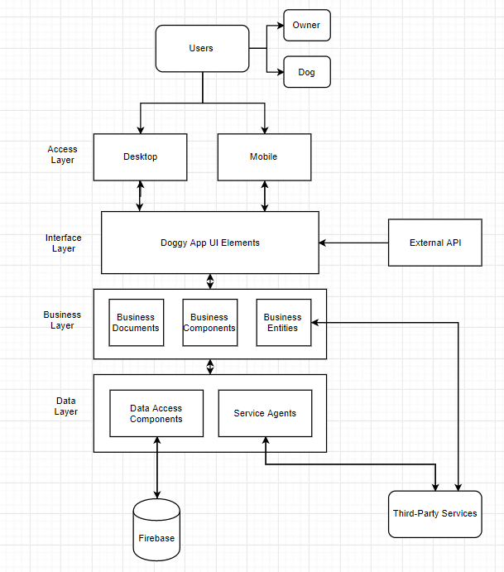

1. Machine Learning in Project

* Image recognition software will ensure dog profiles are actually dogs

1. Language of Machine Learning Code

* Java

1. How Components of Fullstack are Built

* Back-end built by Firebase database, front-end built by dev team

1. Sprint Team Capacity

* Sukriti Agarwal- 5 hrs/week
* Hamza Mekouar- 5 hrs/week
* Shashi Kumar Kadari Mallikarjuna- 5 hrs/week
* Brandon Winn- 5 hrs/week
* Daniel Li- 5 hrs/week
* Dhiren Lalwani- 5 hrs/week
* Total= 30 hours
* Total \*3 Weeks = 90 Work Hours/Sprint